CS 331 (Software Engineering Lab)

Assignment 3

CI/CD Pipeline Automated Failure Recovery System

System Overview
The CI/CD Pipeline Automated Failure Recovery System is an intelligent software solution designed to automatically detect, diagnose, and recover from failures in continuous integration and continuous deployment pipelines. The system monitors pipeline executions, identifies failure patterns, applies recovery strategies, and learns from historical data to improve future recovery success rates.

Data Flow Diagrams (DFD)

Q1. Context Diagram (Level 0 DFD)
The Context Diagram shows the CI/CD Failure Recovery System as a single process with external entities that interact with it.
External Entities:
- Developer: Triggers pipelines, receives notifications
- CI/CD Platform (Jenkins/GitLab): Executes pipelines, sends events
- Version Control System (Git): Provides code changes
- Admin: Configures recovery policies

Context Diagram Structure:
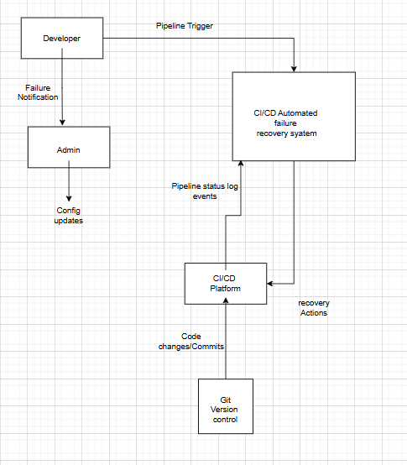

Data Flows:
- Pipeline Trigger: Developer → System (contains build parameters, branch info)
- Pipeline Status/Logs: CI/CD Platform → System (execution status, error logs)
- Code Changes: Version Control → System (commit history, file changes)
- Recovery Actions: System → CI/CD Platform (retry commands, configuration fixes)
- Failure Notifications: System → Developer (alert messages, recovery status)
- Config Updates: Admin → System (recovery policies, threshold settings)
- Recovery Reports: System → Admin (analytics, success rates)

